Fitness Tracker
Centre Number: 12262

Contents Page
Contents Page
Problem Definition
Computational approach
Stakeholders
Questionnaire
Existing Systems Research
How This Research Influenced My Project
Essential Features of the Solution
Hardware Requirements
Software Requirements
Success Criteria
Limitations of the Proposed Solution

Problem Definition

Maintaining a healthy lifestyle can be difficult for many people due to a lack of consistency, motivation, and awareness of their daily activity levels. While individuals may have fitness goals such as improving cardiovascular health, increasing strength, losing weight, or simply staying active, it is often challenging to accurately monitor progress without a structured system.
Many people currently rely on memory, handwritten notes, or multiple separate applications to track exercise routines, calories burned, step counts, sleep patterns, and workout history. These methods can be inconvenient, time-consuming, and unreliable, making it harder for users to identify patterns in their habits or stay motivated over time.
Existing fitness tracking solutions may also be overly complex, require paid subscriptions, or present too much unnecessary information for casual users. This creates a gap for a simple, accessible, and user-friendly application that allows individuals to record and monitor their fitness data efficiently.
The aim of this project is to develop a fitness tracker app that enables users to log workouts, monitor daily activity (such as steps or calories burned), track progress towards personal fitness goals, and view historical performance data in a clear visual format. The application should improve user organisation, encourage healthier habits, and provide an easy way to manage personal fitness information in one place.
This project is intended for individuals who want a straightforward tool to support their fitness journey without the complexity of advanced professional software.

Computational approach

Why a Computer is Suitable

Handles Large Amounts of Data
A fitness tracker needs to store information such as workouts, step counts, calorie records, weight logs, and fitness goals. Over time, this can result in a large amount of data. A computer can store and organise this information efficiently using a database, allowing users to access historical records whenever needed.

Performs Repetitive Tasks Quickly
Users may enter fitness data every day. The system must repeatedly calculate totals, compare results against goals, and update progress charts. A computer can perform these repetitive tasks automatically and much faster than a human.

Produces Consistent Results
The same calculations and processes will always produce the same result when given the same data. This ensures users receive reliable feedback about their fitness progress and removes inconsistencies that could occur with manual calculations.

Reduces Human Error
When calculations are performed manually, mistakes can occur. A computer can automatically calculate totals, generate graphs, and track progress, reducing the chance of errors and improving the accuracy of the information provided.

Stores and Processes Data Efficiently
A database allows user information to be stored securely and retrieved quickly. The system can process data to generate statistics, display progress charts, and monitor goals without requiring users to analyse the information themselves.

Decomposition
The problem can be broken down into smaller, manageable parts such as:
- User account management
- Workout logging
- Weight tracking
- Goal setting
- Progress monitoring
- Database storage
By separating the system into these components, each feature can be designed, developed, and tested individually before being combined into the final solution.

Abstraction
Not all fitness information needs to be stored. The system only focuses on the information required to meet the user’s needs, such as workouts, calories, steps, and weight. Irrelevant details can be ignored, making the system simpler and more efficient.

Algorithms
The system relies on algorithms to process user data such as:
- User enters fitness information.
- Data is validated.
- Information is stored in the database.
- Progress is calculated.
- Results are displayed to the user.
These step-by-step procedures ensure the system operates consistently and efficiently.

Logic
The fitness tracker uses logical decisions to control how data is processed such as:
- IF a username or password is incorrect, access is denied.
- IF a user reaches their daily step goal, a success message is displayed.
- IF a required field is left blank, an error message is shown.
- IF a workout is entered correctly, the data is saved to the database.
These logical decisions help the system respond appropriately to different situations.

Stakeholders
The primary users of this system are individuals who wish to monitor and improve their personal fitness and health. This includes gym users, runners, athletes, and beginners starting a fitness programme.
These users require a system that allows them to store and manage fitness-related information in a central location. The proposed fitness tracker application will enable users to:
- Record workouts, including exercise type, duration, and intensity.
- Track daily metrics such as step count, calories burned, and workout frequency.
- Set personal fitness goals, for example daily step targets or weekly exercise targets.
- View progress over time through stored historical data and graphical summaries.
This solution is appropriate to their needs as it provides a structured and efficient method of monitoring performance, allowing users to identify progress and maintain motivation towards their fitness objectives.
The intended users are expected to have basic to intermediate computing ability, as most users will be familiar with using mobile applications, navigating menus, and inputting data into digital systems. Therefore, the interface must be simple, intuitive, and user-friendly.
Another stakeholder for this project is personal trainers or fitness coaches.
These stakeholders may use the system to review progress data recorded by their clients, allowing them to assess workout consistency, activity levels, and achievement of goals. This enables trainers to make informed recommendations regarding exercise routines and fitness targets.
This is appropriate to their needs because it provides organised and accessible data in one system, reducing reliance on paper-based tracking or communication across multiple platforms.
Personal trainers are expected to have intermediate computing ability, as they are likely to regularly use scheduling software, fitness applications, and digital communication tools.
As the developer, the client is responsible for gathering requirements, designing the interface, implementing functionality, and evaluating whether the completed solution successfully meets user needs.
This is appropriate because direct feedback from intended users can be incorporated throughout development to ensure the final product is fit for purpose.

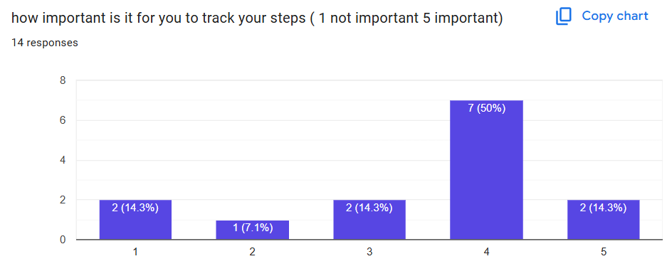
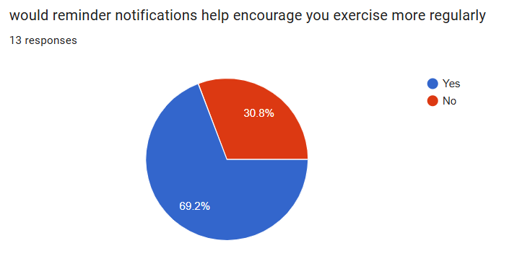
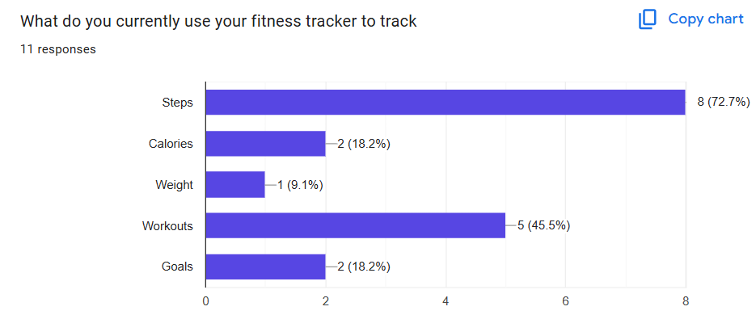
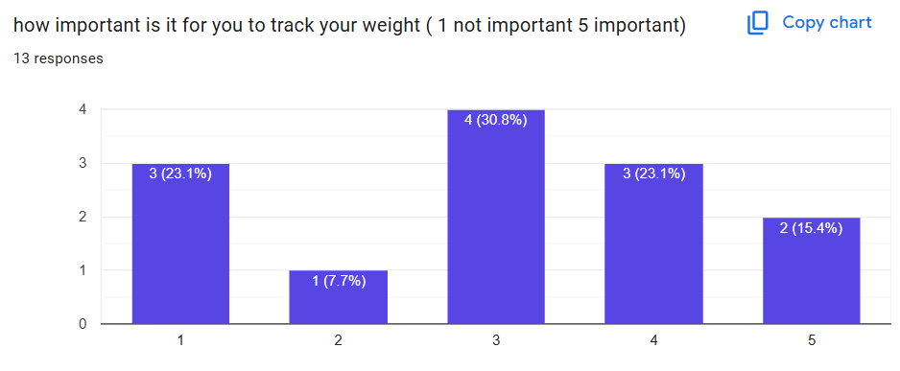
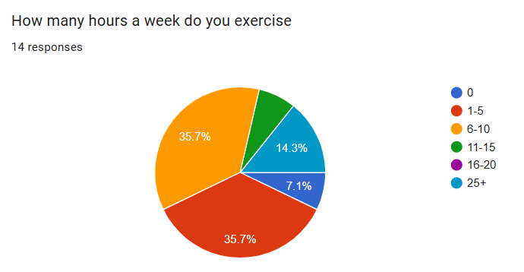
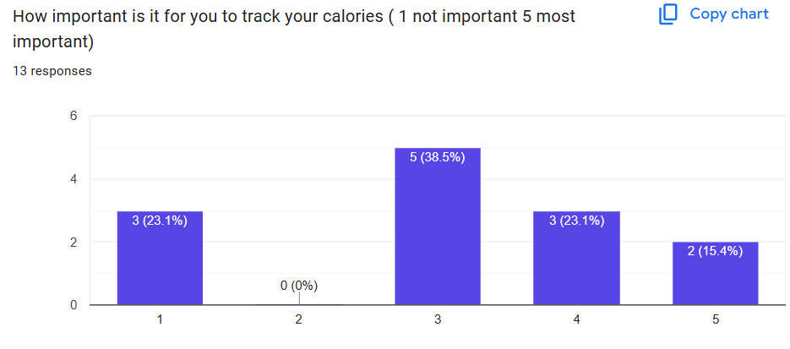
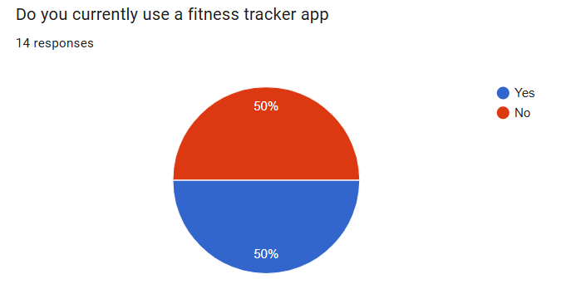
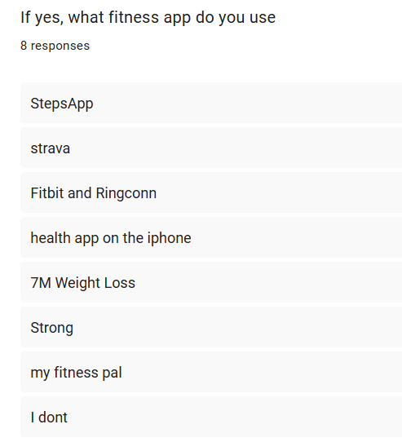
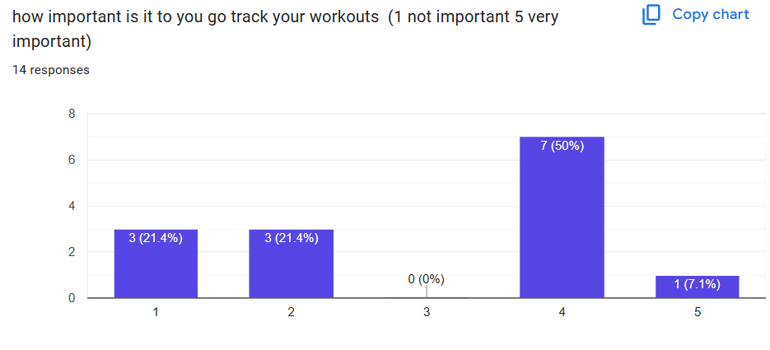
Questionnaire

Existing Systems Research
Existing System | Description | What It Does Well | Limitations | Useful Features for My Project
MyFitnessPal | A fitness app mainly used for calorie counting, food logging, exercise tracking, and weight monitoring. | Large food database, easy meal logging, clear progress graphs, simple goal setting. | Mainly focused on nutrition rather than full fitness tracking. Many advanced features require premium subscription. Relies heavily on manual input. | Goal tracking, daily summaries, progress charts.
Fitbit   | A fitness tracking system linked to wearable devices that automatically tracks health data. | Automatic tracking, clear dashboard, accurate step counting, sleep tracking, activity summaries. | Requires Fitbit hardware for full functionality. Some advanced features require subscription. | Dashboard design, reminders, daily activity summaries.
Strava  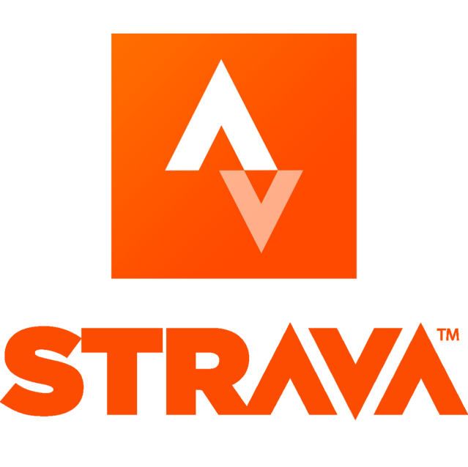 | An app designed mainly for runners and cyclists to track exercise routes and workouts. | GPS route tracking, workout history, challenges, badges, streaks, motivation through achievements. | More suited to athletes than general users. Focused heavily on endurance sports. | Achievement badges, streak tracking, workout history.
Nike Training Club   | A workout-focused app providing guided exercises and training plans. | Beginner-friendly, clean design, workout videos, simple navigation. | More focused on workouts than tracking fitness data such as calories or weight. | Workout logging, simple layout, beginner-friendly interface.

How This Research Influenced My Project

Based on my research, my fitness tracker will combine useful features from existing systems while avoiding their weaknesses.
My system will include:
- Step tracking
- Workout logging
- Calorie tracking
- Weight monitoring
- Goal setting
- Progress charts
- Reminder notifications
I want my system to be simple, clear, and easy to use, especially for beginner users. Unlike some existing systems, my project will not depend on expensive wearable devices or premium subscriptions.

Essential Features of the Solution

Feature | Description | Why It Is Needed | Justification
User Account/Login System | Allows users to create an account and securely log in to their personal fitness tracker. | This is needed so each user can have their own saved progress, goals, and fitness data. | I chose a login system because fitness data is personal and should not be mixed between users. This is better than a shared system with no accounts, which would not be secure or practical.
Step Tracking | Records the number of steps a user takes each day. | Step tracking is one of the most common ways users measure daily activity levels. | Research showed Fitbit is popular because of simple activity monitoring. Including step tracking makes the system useful even for beginner users.
Workout Logging | Allows users to record workouts such as running, gym sessions, or home exercises. | Users need a way to keep track of completed exercise sessions and review their activity history. | I included this because apps like Strava and Nike Training Club focus heavily on exercise logging. It is more flexible than only tracking steps.
Calorie Tracking | Allows users to record calories consumed or burned. | This is useful for users interested in weight loss, muscle gain, or maintaining healthy habits. | Research into MyFitnessPal showed calorie tracking is highly valued by users, so including it improves usefulness.
Weight Monitoring | Lets users record and update their weight over time. | Users need to monitor long-term physical progress. | This was chosen because weight is an important measurable fitness indicator and is simple to implement.
Goal Setting | Users can set goals such as daily steps, calories, or workouts per week. | Goals improve motivation and help users stay consistent. | Research showed apps such as Strava motivate users through goals and achievements, so this feature supports engagement.
Progress Charts/Graphs | Displays fitness progress visually using graphs or charts. | Users need feedback to see improvements over time. | A visual representation is easier to understand than raw numbers alone. This was inspired by MyFitnessPal and Fitbit dashboards.
Reminder Notifications | Sends reminders to log workouts or stay active. | Helps users stay consistent and reduces forgetting to log activities. | Fitbit uses reminders effectively to increase user engagement, so I included a simplified version.
Database Storage | Stores all user information such as workouts, calories, goals, and weight history. | Without storage, user progress would be lost after closing the application. | Persistent data storage is essential for any tracking system because users need long-term records.

Hardware Requirements
Requirement | Justification
A computer or laptop capable of running Windows 10 or later | The fitness tracker will be developed and tested on a computer. Windows 10 or later provides compatibility with the required software and development tools.
At least 4GB RAM | The application does not require intensive processing, so 4GB RAM is sufficient to run the program, database, and development environment smoothly.
Keyboard and mouse | Required for entering fitness data, navigating the application, and testing the user interface.
Minimum 500MB free storage space | Needed to store the application files, database, user fitness records, and development software.
Internet connection (optional) | Required for downloading software updates, libraries, and research materials during development. The fitness tracker itself can function without a constant internet connection.

Software Requirements
Requirement | Justification
Python 3.12 | Python will be used as the main programming language because it supports object-oriented programming, data handling, and GUI development.
SQLite | SQLite will be used to store user accounts, workout records, goals, weight logs, and other fitness data. It is lightweight and easy to integrate with Python.
Visual Studio Code | Provides an efficient environment for writing, debugging, and testing the code. It supports Python development and useful extensions.
Tkinter | Tkinter will be used to create the graphical user interface (GUI). It is included with Python and is suitable for creating forms, buttons, and dashboards.
Matplotlib | Used to generate charts and graphs showing fitness progress over time. This helps users visualise their performance.
Web Browser | Required for researching fitness tracking systems, accessing documentation, and downloading software during development.

Success Criteria
No. | Criteria | Justification | Achievable | Realistic
1 | The system must provide a secure user authentication system that enables users to register, log in, and log out using a unique username and password. This feature is essential because the application stores personal fitness information, including workout history, weight measurements, calorie records, and individual fitness goals. | This feature ensures that each user’s fitness information remains private and secure by restricting access to authorised users only. Since the application stores personal data such as workout history, weight measurements, calorie records, and fitness goals, it is important that this information cannot be viewed or edited by anyone else. Requiring a unique username and password protects user privacy, prevents unauthorised access, and allows each user to safely access their own fitness records whenever they log in. | Can be implemented using a login form and basic authentication methods. | User authentication is a standard feature in fitness applications.
2 | The system must store all user fitness data in a secure database so that information is saved permanently and is not lost when the application is closed. This includes user account details, workout history, step counts, weight records, calorie logs, and fitness goals. Users should be able to log back into their account at any time and continue tracking their progress from where they left off. | Storing data in a database is essential because users need to monitor their fitness progress over time. If the data was not saved permanently, users would lose all of their records each time they closed the application, making the fitness tracker ineffective. Using a database provides a reliable and organised way to store and retrieve information, ensuring that user records remain accurate, secure, and available whenever they are needed. | Databases such as SQLite or MySQL can be used to store and retrieve data. | Permanent data storage is essential for any fitness tracking system.
3 | The system must allow users to log their workouts by entering important details such as the type of activity, the duration of the workout, the date it was completed, and, where appropriate, additional information such as distance or calories burned. Each workout should be saved to the user’s account so that they can build a complete history of their fitness activities and review their progress over time. | Workout logging is one of the main functions of a fitness tracker because it allows users to keep an accurate record of their physical activity. By storing details such as the activity type, duration, and date, users can monitor how often they exercise, identify improvements in their fitness levels, and stay motivated to achieve their goals. This feature was chosen because research into existing fitness applications, such as Strava and Nike Training Club, showed that keeping a workout history is an essential feature for helping users track their progress and maintain a consistent exercise routine. | Data can be entered through forms and stored in the database. | This is a core feature found in most fitness applications.
4 | The system must allow users to record and monitor their weight over time by entering regular weight measurements either daily or weekly, which are stored in the system and displayed as a history so that users can track changes in their body weight over a period of time. | Tracking weight over time is an important feature in a fitness tracker because it allows users to see long-term trends in their physical progress rather than relying on short-term changes. By storing each weight entry in a database, the system can display historical records and show whether the user is gaining, losing, or maintaining weight. This helps users evaluate whether their fitness routine is effective and supports goal setting such as weight loss or muscle gain. This feature was included because research into existing applications like MyFitnessPal showed that weight tracking is a key function for users who want to monitor health and fitness improvements in a clear and measurable way. | Weight entries can be stored and displayed using database records. | This is a common and practical feature in fitness trackers.
5 | The system must allow users to set personalised fitness goals, such as daily step targets, weekly workout targets, calorie limits, or weight-related goals. These goals should be stored within the user’s account and updated as the user enters new fitness data, allowing them to track their progress towards each target over time. | Goal setting is an important feature in a fitness tracker because it helps users stay motivated and gives them clear targets to work towards. Without goals, users may find it harder to measure success or maintain consistency in their fitness routine. By allowing users to set and update their own goals, the system becomes more personalised and engaging. This feature was included because research into fitness applications such as Strava and Fitbit showed that goal tracking and achievement systems are widely used to encourage users to remain active and monitor their progress effectively. | Goal-setting features can be implemented using simple forms and database storage. | Goal tracking is widely used in fitness applications and is realistic to develop.
6 | The system must display the user’s fitness progress through charts and graphs that present information such as weight changes, step counts, workout frequency, and calorie intake over a period of time. These visual representations should update automatically whenever new data is added, allowing users to easily compare their current performance with previous results. | Displaying progress using charts and graphs makes it easier for users to understand their fitness data than viewing numbers alone. Visual feedback helps users identify trends, recognise improvements, and see whether they are meeting their fitness goals. This can increase motivation and encourage users to stay consistent with their exercise routine. This feature was chosen because research into existing fitness applications, such as Fitbit and MyFitnessPal, showed that visual progress tracking is a key feature that helps users monitor their performance and remain engaged with the application. | Libraries such as Chart.js can generate charts automatically. | Progress visualisation is a standard feature in modern fitness systems.
7 | The system must validate all user inputs before saving them to the database to ensure that the information entered is complete and accurate. For example, the system should check that required fields are not left blank, numerical values such as weight or step count contain only valid numbers, and invalid or unrealistic values cannot be submitted. If an error is detected, the user should be shown a clear message explaining what needs to be corrected before the data can be saved. | Input validation is essential because it helps maintain the accuracy and reliability of the data stored in the system. Without validation, users could accidentally enter incorrect or incomplete information, which could lead to inaccurate progress reports and make the fitness tracker less useful. By checking the data before it is saved, the system reduces errors and ensures that users can rely on the information displayed. This feature was included because data validation is a standard practice in software development and is used in many fitness applications to improve usability and prevent invalid data from being stored. | Can be implemented using conditional statements and form validation rules. | This is a standard requirement for reliable software.
8 | The system must allow users to view their workout and fitness history by displaying previously recorded information, including workout sessions, step counts, weight records, calorie logs, and completed fitness goals. Users should be able to access these records at any time so they can review their past activities and monitor their progress over days, weeks, or months. | Being able to view previous fitness records is important because it allows users to monitor their long-term progress and identify patterns in their activity levels. By comparing past and current results, users can see whether they are improving, maintaining, or falling behind their fitness goals. This feature also helps users stay motivated, as they can clearly see the progress they have made over time. It was included because research into fitness applications such as Fitbit and Strava showed that viewing workout history is a key feature that enables users to track their performance and make informed decisions about their fitness routines. | Stored records can be retrieved and displayed from the database. | Historical data is essential for tracking long-term fitness progress.
9 | The system must provide a simple and easy-to-use interface so that users can access all key features without confusion. Main functions such as logging workouts, updating weight, setting goals, and viewing progress will be clearly organised on a main menu or home screen. The layout will be consistent throughout the system, with clear labels, readable text, and appropriately sized buttons to support easy navigation. Tasks will be designed to take only a few steps to complete, helping users interact with the system quickly and efficiently, even if they are using it for the first time. | A clear interface improves usability and makes the system more accessible, especially for beginner users who may not be familiar with fitness tracking applications. When the layout is simple, consistent, and easy to navigate, users can find features quickly without feeling overwhelmed or confused. This reduces the likelihood of errors and makes the overall experience smoother and more efficient, encouraging users to interact with the system more regularly. It also ensures that users can focus on their fitness goals rather than struggling to understand how the application works, which ultimately makes the system more effective and user-friendly. | Can be achieved through careful layout design and user testing. | Simplicity was identified as an important requirement during research.
10 | The system must generate reminders or notifications for users to stay active or log workouts. | Reminders encourage consistency and help users maintain fitness habits. | Can be implemented using scheduled notifications or alerts. | Many successful fitness apps use reminders to increase user engagement.

Limitations of the Proposed Solution
Limitation | Explanation | Justification
Manual Data Entry | Users will need to manually enter important information such as the workouts they have completed, their daily calorie intake, and any changes in their weight. This can create a number of issues regarding the accuracy and reliability of the data stored within the system. Since the process relies entirely on the user, there is always a risk that information may be entered incorrectly or not entered at all.  For example, users may forget to log a workout after exercising, estimate their calorie intake inaccurately, or accidentally enter the wrong weight measurement. Some users may also lose motivation over time and stop updating their records regularly, causing gaps in the data. If the information stored is incomplete or incorrect, the application may generate inaccurate progress reports and misleading statistics.  This could have a negative impact on the user experience, as users may not be able to accurately track their fitness journey or assess whether they are making progress towards their goals. In addition, inaccurate data could affect features such as calorie tracking, weight-loss predictions, workout recommendations, and performance analysis. As a result, the overall effectiveness of the application may be reduced, making it less useful for helping users achieve and maintain their health and fitness objectives. | Integrating automatic tracking through wearable devices such as smartwatches and fitness bands would significantly increase the complexity of the project. The system would need to connect with external devices and third-party platforms, requiring the use of APIs, data synchronisation features, and additional security measures to protect user information. Developing and testing these integrations would take a considerable amount of time and technical expertise, which could make the project more difficult to complete within the available timeframe.  Supporting a wide range of wearable devices could create compatibility issues, as different brands often use different software, data formats, and connection methods. This would increase development costs and require ongoing maintenance to ensure that the application continues to work correctly when devices or operating systems are updated. There is also the risk that connection errors or synchronisation failures could prevent data from being transferred accurately, leading to frustration for users.  By requiring users to manually enter information such as workouts completed, calories consumed, and weight measurements, the system remains much simpler and more reliable to develop. Manual data entry eliminates the need for complex integrations while still providing users with the core functionality needed to monitor their fitness progress. Users are able to record their activities, track changes over time, and view their achievements without relying on external hardware. This approach ensures that the application remains accessible to all users, including those who do not own wearable devices, while allowing the project to focus on delivering its main purpose effectively. Furthermore, reducing the technical complexity of the system makes it easier to test, maintain, and improve in the future, helping to ensure a more stable and user-friendly experience.
No Integration with Fitness Wearables | The system will not automatically collect fitness data from wearable devices such as Fitbit trackers, smartwatches, or other health-monitoring technologies. Instead, users will be responsible for manually entering information about their daily activities, workouts, calorie intake, and other fitness-related data. This means that if a user completes a run, goes to the gym, or takes part in another form of exercise, they must record the activity themselves within the application.  Automatic integration with wearable devices would require the system to connect to external platforms and process data from multiple sources, which would significantly increase the complexity of the project. Different devices use different software and communication methods, meaning additional development time would be needed to ensure compatibility and reliable data transfer. By excluding this feature, the system remains simpler to design, develop, and maintain.  Although manual entry may require more effort from users, it still allows them to effectively monitor and manage their fitness progress. Users can record important information whenever they choose and maintain a complete history of their activities without needing to own a specific wearable device. This approach also makes the application accessible to a wider range of users, including those who do not use fitness trackers or smartwatches. While manual input may not be as convenient as automatic tracking, it provides a practical and achievable solution that supports the core purpose of the system while keeping development requirements realistic. | Connecting the system to external devices such as fitness trackers, smartwatches, and health-monitoring applications would require the use of APIs to allow data to be exchanged between different platforms. Implementing these connections would involve a greater level of technical knowledge, as developers would need to understand how to authenticate users, manage data transfers, handle potential connection errors, and ensure that information is stored securely. In addition, each device manufacturer may provide different APIs and requirements, meaning extra time would be needed to research, develop, test, and maintain these integrations.  Including support for external devices would also increase the overall complexity of the project. The system would need to be tested across multiple devices and software versions to ensure that data is transferred accurately and consistently. Any changes made by third-party providers could require further updates to the system, creating additional maintenance requirements even after development has been completed. These factors would significantly increase both the workload and development time needed for the project.  By focusing on the core features of the application rather than complex external integrations, more time can be dedicated to ensuring that essential functions such as workout tracking, calorie monitoring, goal setting, and progress reporting are implemented effectively. A standalone solution still meets the main requirements of the system and provides users with the tools they need to manage their fitness journey. This approach helps keep the project manageable, reduces the risk of technical issues, and increases the likelihood of delivering a reliable and fully functional final product within the available development timeframe.
Limited Health Metrics | The system is designed to focus on the collection and monitoring of key fitness data that is most relevant to helping users achieve their health and exercise goals. This includes information such as workouts completed, calories consumed or burned, daily step counts, and changes in body weight. These features provide users with a clear overview of their fitness progress and allow them to track important trends over time without making the system unnecessarily complex.  Advanced health metrics such as heart rate, blood oxygen levels, sleep quality, sleep duration, and stress levels will not be included within this project. Collecting and analysing this type of data would typically require integration with specialised wearable devices, such as smartwatches and fitness trackers, as well as access to additional sensors and third-party health platforms. Implementing these features would require more advanced development techniques, increased testing, and additional security measures to ensure that sensitive health information is handled correctly.  Including advanced health monitoring would also increase the complexity of both the user interface and the underlying system. Users would need access to compatible devices, and the application would need to process and display large amounts of data in a meaningful way. This could make the system more difficult to develop, maintain, and use, particularly for users who are primarily interested in tracking their exercise routines and basic fitness progress.  By focusing on core fitness metrics instead, the system remains practical, user-friendly, and achievable within the project. Users will still be able to monitor the most important aspects of their fitness journey, including their activity levels, calorie management, and weight changes. This ensures that the application fulfils its primary purpose while keeping development requirements realistic and allowing greater focus on delivering reliable and effective core functionality. | Advanced features such as heart rate monitoring, blood oxygen tracking, sleep analysis, and stress measurement typically rely on specialised hardware and sensors that are not available on standard computers or mobile devices. To collect this type of information accurately, users would usually need wearable technology such as smartwatches, fitness bands, or dedicated health-monitoring devices. These devices contain built-in sensors that continuously gather physiological data and transmit it to an application for analysis.  Supporting these advanced features would require the system to integrate with a variety of external devices and platforms, increasing the technical complexity of the project. Additional development would be needed to establish secure connections, process sensor data, manage compatibility between different devices, and ensure that the information collected is accurate and reliable. Extensive testing would be required to verify that all supported devices function correctly with the system.  The primary aim of the proposed solution is to provide users with an effective and accessible way to monitor their fitness progress. Research into the target users identified that the most important features are the ability to track workouts, monitor calorie intake and expenditure, record daily step counts, and keep track of weight changes over time. These features provide users with the essential information needed to manage their fitness goals and measure their progress effectively.  By focusing on these core fitness tracking functions, the system can remain simple, reliable, and easy to use while still meeting the needs of its intended users. Limiting the project to the most important features also allows more development time to be spent refining and improving the application's main functionality, resulting in a more stable and user-friendly final product.
Dependence on User Accuracy | The accuracy and usefulness of the system depend heavily on the quality of the data entered by users. Since the application relies on manual input for information such as workouts completed, calorie intake, step counts, and weight measurements, users must ensure that the data they provide is accurate and up to date. The system can only analyse and report on the information it receives, meaning that any errors in the data entered will affect the reliability of the results produced.  There are several ways in which inaccurate data may occur. Users may accidentally enter incorrect values, forget to record an activity, estimate calorie intake incorrectly, or enter information at a later date and struggle to remember the exact details. For example, a user might record a workout duration incorrectly, underestimate the number of calories consumed during the day, or enter the wrong body weight measurement. Even small errors can accumulate over time and reduce the accuracy of the user's fitness records.  If inaccurate information is entered, the system may generate misleading progress reports and statistics. This could result in users believing they are making more or less progress than they actually are. For instance, incorrect calorie data could affect calculations related to weight management goals, while missing workout records could lead to an incomplete picture of a user's activity levels. As a result, users may make decisions based on inaccurate information, reducing the effectiveness of the system as a fitness monitoring tool.  Despite this limitation, manual data entry remains a practical solution for the scope of the project. Users are given full control over the information they record, and when data is entered carefully and consistently, the system can still provide valuable insights into fitness progress and performance. Encouraging users to update their records regularly can help improve data accuracy and ensure that the reports generated by the application remain as reliable and useful as possible. | Rather than relying on complex integrations with external devices or automated data collection methods, users can manually record information such as workouts completed, calories consumed, daily step counts, and weight measurements. This approach allows the system to meet its core objectives without requiring advanced technologies that would significantly increase the complexity of the project.  Using manually entered data also makes the application more accessible, as users do not need to own fitness trackers, smartwatches, or other specialised equipment in order to use the system. Any user can access the application and record their fitness information regardless of the devices they own. This ensures that the system remains inclusive and easy to use while still providing valuable fitness tracking functionality.  Although manual data entry introduces the possibility of human error, measures can be put in place to reduce the likelihood of incorrect information being entered. Validation checks can be used to ensure that data entered by users falls within reasonable and acceptable ranges. For example, the system can prevent users from entering negative calorie values, unrealistic step counts, or invalid weight measurements. Input fields can also be designed to accept only the correct data type, such as numbers where numerical values are required.  While validation checks cannot guarantee that all information entered is completely accurate, they can significantly reduce common input mistakes and improve the overall quality of the data stored within the system. As a result, the application can generate more reliable reports and progress summaries while maintaining a simple design.
Limited Notification Features | The reminder notification feature is designed to help users stay consistent with their fitness goals by prompting them to log workouts, update progress records, or complete other fitness-related activities. However, the effectiveness of these reminders may depend on the device being used and the way the application is installed and configured. In some cases, notifications may only function correctly when the application is open, running in the background, or installed on a device that supports notification services.  Different devices and operating systems manage notifications in different ways. Some devices may restrict background processes to conserve battery life, while users may choose to disable notifications entirely through their device settings. As a result, there is no guarantee that every reminder will be delivered or displayed exactly as intended on all devices. This could reduce the effectiveness of the reminder system for some users.  Implementing a fully featured notification system that works across all devices, platforms, and operating systems would require additional development time and technical complexity. It may involve platform-specific programming, background services, and extensive testing to ensure compatibility with different devices.  Despite this limitation, reminder notifications can still provide value when supported by the user's device and application settings. They can encourage users to remain engaged with the system, develop healthier habits, and maintain consistent fitness tracking. By including a basic reminder feature, the application can support user motivation while keeping the project realistic, manageable, and focused on its core functionality. | Developing an advanced push notification system would significantly increase the complexity of the project. A fully featured notification system would need to support real-time alerts, background processing, personalised reminders, scheduling functionality, and compatibility across multiple devices and operating systems. Implementing these features would require additional programming knowledge, more extensive testing, and a greater amount of development time.  Advanced notification systems also rely on services provided by operating systems and third-party platforms. I would need to configure notification permissions, manage delivery services, handle situations where devices are offline, and ensure that reminders are delivered at the correct time. Different devices may process notifications differently, creating further challenges when attempting to provide a consistent user experience across all platforms.  Including these advanced capabilities would increase both the workload and maintenance requirements of the application. Future software updates or changes to notification services could require modifications to the system, resulting in additional development effort even after the project has been completed.  By using simple reminder notifications instead, the system can still provide meaningful support to users without introducing unnecessary complexity. Basic reminders can encourage users to log workouts, update their progress, and remain engaged with their fitness goals. While these reminders may not offer the same level of functionality as advanced push notification systems, they are sufficient for the needs of the project and help maintain a balance between usability, functionality, and realistic development requirements.
Requires Internet Access (if web-based) | If the fitness tracker is developed as a web application, users may require an internet connection to access their accounts and view their stored data. Since information such as workout records, calorie logs, fitness goals, and progress reports would typically be stored on a remote server or database, the application would need to communicate with that server whenever data is retrieved or updated. Without an active internet connection, users may be unable to access some or all of the system's features.  This dependency on internet connectivity could create limitations for users who have unreliable network access or who wish to use the application while travelling. For example, a user may be unable to log a workout, update their progress, or view historical fitness data if they are in an area with poor signal or no internet connection. This could reduce the convenience of the system in certain situations and may affect the user experience.  Providing full offline functionality would significantly increase the complexity of the project. The application would need to store data locally on the user's device, synchronize information when an internet connection becomes available, and manage potential conflicts between local and online records. Implementing these features would require additional development time, testing, and maintenance to ensure that data remains accurate and consistent across different devices and sessions. | A web-based system offers several advantages that make it a suitable choice for the fitness tracker. One of the main benefits is accessibility, as users can access their accounts from a variety of devices, including desktop computers, laptops, tablets, and smartphones, provided they have an internet connection and a web browser. This flexibility allows users to view and update their fitness information wherever it is most convenient for them without needing to install separate software on each device.  Another significant advantage is simplified data management. Because user information is stored centrally within a database, fitness records, goals, and progress reports can be accessed consistently across different devices. Users do not need to manually transfer data between devices, and updates made on one device are immediately available when accessing the system from another. This helps create a more seamless user experience and reduces the risk of data becoming inconsistent or outdated.  Developing the application as a web-based system also simplifies maintenance and future updates. Any improvements, bug fixes, or feature enhancements can be implemented on the server and made available to all users immediately. This eliminates the need for users to download and install software updates themselves, making the system easier to manage from both a development and user perspective.
Basic Security Measures | The fitness tracker will use a username and password authentication system to control access to user accounts and protect personal information. Users will be required to create login credentials when registering for an account and will need to enter these details whenever they wish to access their fitness records. This provides a basic level of security by ensuring that only authorised users can view or modify the data stored within the system.  More advanced security measures, such as two-factor authentication, biometric verification, or authentication through external security providers, may not be included within the project. Implementing these features would require additional development work, more complex account management processes, and potentially the use of third-party services. This would increase both the technical complexity and the time required to develop and test the system.  Including advanced authentication methods would also create additional considerations for users. For example, two-factor authentication often requires access to a mobile device, email account, or authentication application in order to verify a login attempt. While these features can provide greater security, they may also make the login process more complicated and less convenient for some users, particularly when the system is intended primarily for educational purposes. | Basic authentication is appropriate for the scale and purpose of the fitness tracker project. The system's primary aim is allowing users to record workouts, monitor calorie intake and expenditure, track daily activity, and view their fitness progress over time. As the application is not intended to store highly sensitive financial, medical, or government-related information, a standard username and password login system provides a suitable level of protection for the data being collected.  A username and password authentication process helps ensure that users can only access their own accounts and personal fitness records. This prevents unauthorised users from viewing or modifying information stored within the system while keeping the login process simple and easy to understand. Most users are already familiar with this method of authentication, reducing the need for additional training or support when using the application.  Implementing more advanced security features would increase the complexity of the project considerably. Features such as two-factor authentication, biometric verification, account recovery services, and advanced encryption systems would require additional programming, testing, and maintenance. These features are more commonly associated with large-scale commercial applications that manage highly sensitive data and therefore fall outside the requirements of this project.
Limited Data Analysis | The fitness tracker will provide users with simple charts and progress tracking tools to help them monitor their fitness journey. Information such as workouts completed, calories consumed or burned, daily step counts, and weight changes can be displayed using clear graphs and visual summaries. These features allow users to identify trends in their activity levels and measure their progress towards personal fitness goals over time.  While the system will present recorded data in an easy-to-understand format, it will not include advanced fitness recommendations or AI-generated insights. Features such as personalised workout suggestions, automated nutritional advice, predictive progress analysis, or intelligent goal recommendations would require more sophisticated algorithms, larger datasets, and potentially machine learning technologies. Implementing these capabilities would significantly increase the technical complexity of the project.  Developing advanced recommendation systems would also require careful consideration of data accuracy and reliability. In order to generate meaningful advice, the system would need access to large amounts of detailed user information and would need to analyse that information correctly. Incorrect recommendations could reduce user trust in the application and may lead to users making decisions based on inaccurate guidance. Extensive testing and validation would therefore be required to ensure that any recommendations produced are appropriate and reliable. | Advanced analytics features would require significantly more complex development than simple progress tracking tools. Functions such as predictive fitness analysis, personalised recommendations, performance forecasting, and AI-generated insights rely on sophisticated algorithms that can identify patterns and relationships within large amounts of data. Developing these systems would require a greater level of technical knowledge and substantially increase the overall complexity of the project.  In addition to advanced algorithms, meaningful analytics often depend on access to large datasets. To produce accurate recommendations or predictions, the system would need extensive historical data from users and potentially information gathered from external sources. Collecting, storing, and processing this volume of data would introduce additional technical challenges, including database management, data validation, performance optimisation, and security considerations.  Advanced analytics systems also require extensive testing to ensure that the information generated is accurate and reliable. If predictions or recommendations are incorrect, users may lose confidence in the application and the value it provides. Ensuring that analytical results are trustworthy would require additional development time, ongoing refinement, and more complex evaluation processes than those needed for standard reporting features.

Design Module

1. User Account Management
1.1 user registration
1.2 login system
1.3 account stores
Without user accounts, all fitness data would be mixed together, making the system impractical and insecure. A login system ensures that users can access only their own fitness information.

2. Fitness Data Input
2.1 steps
2.2 weight
2.3 calorie
The system cannot track fitness progress unless data is entered. Providing structured input forms ensures information is collected consistently and accurately.

3. Data Validation
3.1 validate inputs (no empty fields, weight values must be numbers, negative values
Cant be entered.
Validation improves data quality and prevents errors from being stored in the database.

4. Data Storage
4.1 store user details
4.2 stores workout history
4.3 store weight records
4.4 store step counts
4.5 store goals
Without data storage, users would lose their progress each time they close the application. A database allows information to be stored and retrieved efficiently.

5. Goal Management
5.1 daily step goals
5.2 weekly workout goals
5.3 weight targets
Goals help motivate users and provide a clear measure of success. Research showed that goal-setting is a key feature in many successful fitness applications.

6. Progress Tracking and Analysis
6.1 progress summaries
6.2 statistics
6.3 charts and graphs
Raw data can be difficult to interpret. Visual progress tracking makes it easier for users to identify trends and stay motivated.

7. Notifications and Reminders
7.1 reminder to log a workout
7.2 reminder to reach daily step goals
Reminders encourage consistency and improve user engagement with the system.

8. User Interface
8.1 navigation menus
8.2 input forms
8.3 progress dashboards
8.4 charts & reports
A clear and user-friendly interface improves usability and ensures users can access features without difficulty.

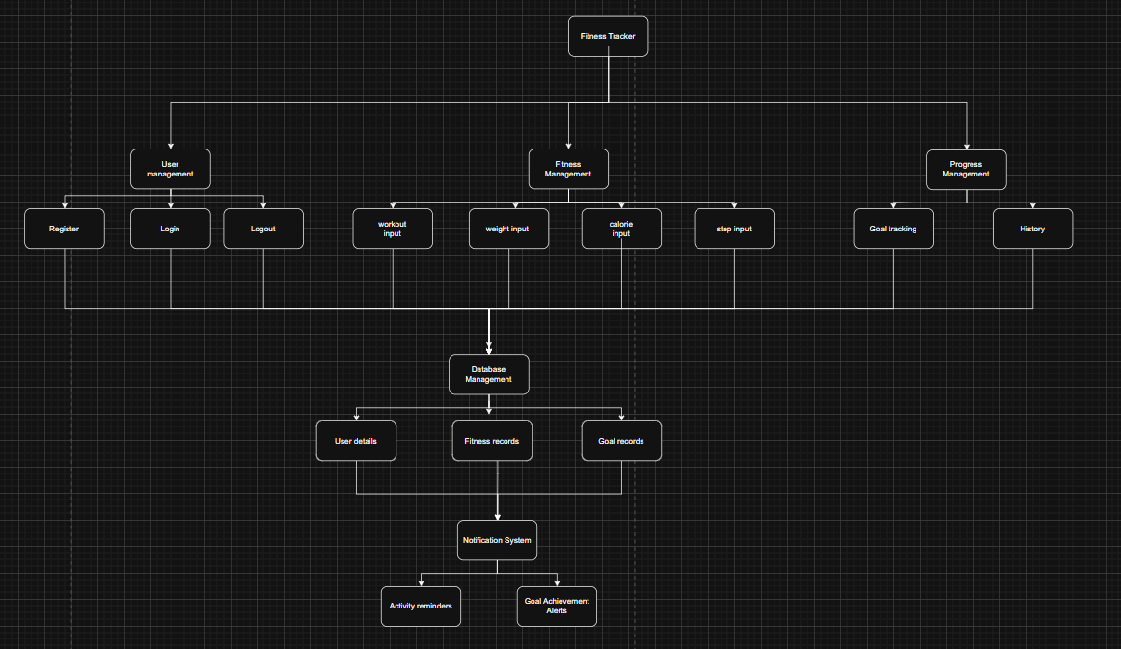
Hierarchy Diagram

Module | Purpose | Main Functions | How It Fits Into the Wider System
User Management | Manages user accounts and controls access to the fitness tracker. | It create a new account, log in using username and password, log out of the system, check that login details are correct, keep each user’s data separate | This is the first module the user interacts with. It ensures that users can securely access their own fitness information and prevents one user’s data from being accessed by another user.
Fitness Management | Allows users to record and manage their fitness information. | Log workouts, Record workout type, duration and date, Record daily steps, Record calorie intake/burned, Record weight, Edit or delete fitness records | This is the main data input part of the system. The information entered here is sent to the database and is later used by the Progress Management module to display the user’s progress.
Goal Management | Allows users to create and manage personalised fitness targets. | Set daily step goals, Set weekly workout goals, Set weight goals, Edit existing goals, Compare current progress with targets | This module uses data from Fitness Management to determine whether the user is making progress towards their goals. It also provides information for the Notification System.
Progress Management | Allows users to view and understand their fitness progress. | Display workout history, Display weight changes, Display step progress, Display calorie information, Generate charts and graphs, Compare progress with goals | This module retrieves information from the database and turns it into useful outputs. It allows users to see trends and understand how their fitness has changed over time.
Database Management | Stores and retrieves all information used by the fitness tracker. | Store user account details, Store workout records, Store steps and calories, Store weight records, Store fitness goals, Retrieve previous records, Update or delete records | The database is connected to most other modules and acts as the central storage system. It ensures that information is not lost when the user closes the application.
Notification System | Keeps users motivated and reminds them to maintain their fitness routine. | Remind users to log workouts, Remind users about fitness goals, Notify users when a goal is achieved, Display motivational messages | This module uses information from the Fitness Management and Goal Management modules to determine when a reminder or achievement notification should be displayed.
Input Validation | Checks that information entered by the user is valid before it is processed or stored. | Check for empty fields, Check that numerical values are valid, Prevent negative or unrealistic values where appropriate, Display error messages, Prevent invalid data from being saved | This works alongside the Fitness Management and User Management modules. It ensures that incorrect information does not enter the database and affect progress calculations.
User Interface | Provides the screens and controls that allow the user to interact with the system. | Login and registration screens, Fitness data entry forms, Dashboard, Navigation buttons, Progress charts, Error and success messages | The user interface connects the user to all of the other modules. It provides a simple way for users to enter information and view the results produced by the system. N

